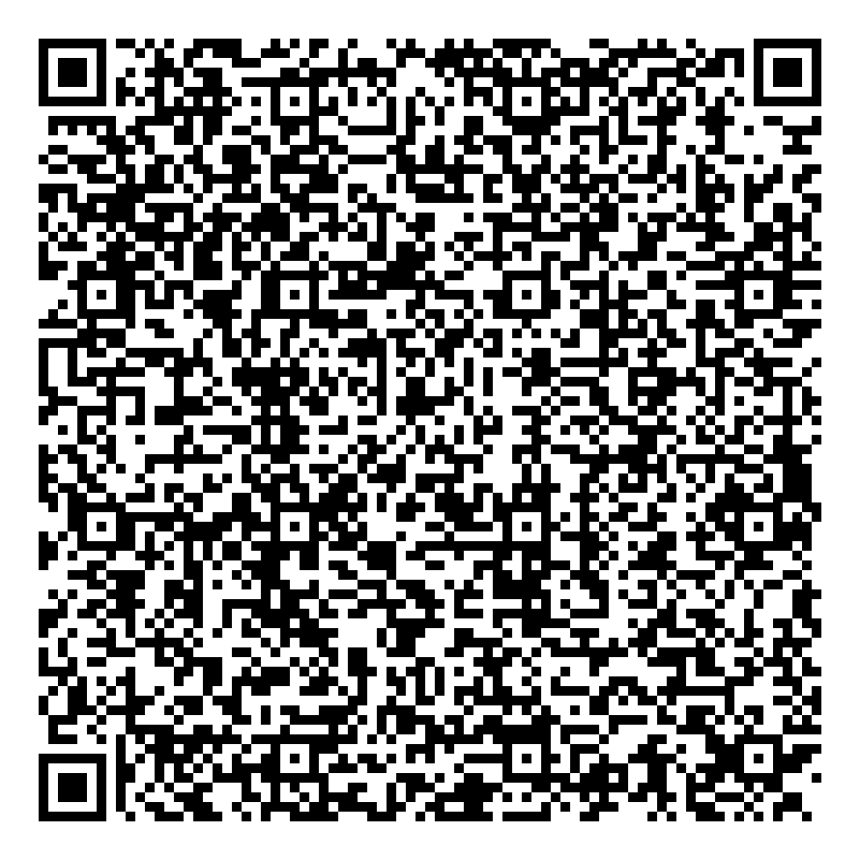
Ramadan times for Khaerdara, Bangladesh
Tue 17 Feb 2026 - Wed 18 Mar 2026
High Latitude Method: None
Prayer Calculation Method: University of Islamic Sciences
Asar Calculation Method: Shafi

Date | Day | Fajr | Suhur | Sunrise | Dhuhr | Asr | Iftar | Maghrib | Isha
17 | Tue | 5:20 | 5:20 | 6:37 | 12:18 | 3:33 | 5:59 | 5:59 | 7:16
18 | Wed | 5:20 | 5:20 | 6:36 | 12:18 | 3:34 | 6:00 | 6:00 | 7:16
19 | Thu | 5:19 | 5:19 | 6:36 | 12:18 | 3:34 | 6:00 | 6:00 | 7:17
20 | Fri | 5:18 | 5:18 | 6:35 | 12:18 | 3:34 | 6:01 | 6:01 | 7:17
21 | Sat | 5:18 | 5:18 | 6:34 | 12:18 | 3:35 | 6:02 | 6:02 | 7:18
22 | Sun | 5:17 | 5:17 | 6:33 | 12:17 | 3:35 | 6:02 | 6:02 | 7:19
23 | Mon | 5:16 | 5:16 | 6:32 | 12:17 | 3:35 | 6:03 | 6:03 | 7:19
24 | Tue | 5:15 | 5:15 | 6:32 | 12:17 | 3:36 | 6:03 | 6:03 | 7:20
25 | Wed | 5:14 | 5:14 | 6:31 | 12:17 | 3:36 | 6:04 | 6:04 | 7:20
26 | Thu | 5:14 | 5:14 | 6:30 | 12:17 | 3:36 | 6:04 | 6:04 | 7:21
27 | Fri | 5:13 | 5:13 | 6:29 | 12:17 | 3:36 | 6:05 | 6:05 | 7:21
28 | Sat | 5:12 | 5:12 | 6:28 | 12:17 | 3:36 | 6:05 | 6:05 | 7:22
1 | Sun | 5:11 | 5:11 | 6:27 | 12:16 | 3:37 | 6:06 | 6:06 | 7:22
2 | Mon | 5:10 | 5:10 | 6:26 | 12:16 | 3:37 | 6:06 | 6:06 | 7:22
3 | Tue | 5:09 | 5:09 | 6:25 | 12:16 | 3:37 | 6:07 | 6:07 | 7:23
4 | Wed | 5:08 | 5:08 | 6:24 | 12:16 | 3:37 | 6:07 | 6:07 | 7:23
5 | Thu | 5:07 | 5:07 | 6:23 | 12:16 | 3:37 | 6:08 | 6:08 | 7:24
6 | Fri | 5:07 | 5:07 | 6:22 | 12:15 | 3:37 | 6:09 | 6:09 | 7:24
7 | Sat | 5:06 | 5:06 | 6:21 | 12:15 | 3:37 | 6:09 | 6:09 | 7:25
8 | Sun | 5:05 | 5:05 | 6:21 | 12:15 | 3:38 | 6:09 | 6:09 | 7:25
9 | Mon | 5:04 | 5:04 | 6:20 | 12:15 | 3:38 | 6:10 | 6:10 | 7:26
10 | Tue | 5:03 | 5:03 | 6:19 | 12:14 | 3:38 | 6:10 | 6:10 | 7:26
11 | Wed | 5:02 | 5:02 | 6:18 | 12:14 | 3:38 | 6:11 | 6:11 | 7:27
12 | Thu | 5:01 | 5:01 | 6:17 | 12:14 | 3:38 | 6:11 | 6:11 | 7:27
13 | Fri | 5:00 | 5:00 | 6:16 | 12:14 | 3:38 | 6:12 | 6:12 | 7:28
14 | Sat | 4:59 | 4:59 | 6:15 | 12:13 | 3:38 | 6:12 | 6:12 | 7:28
15 | Sun | 4:58 | 4:58 | 6:14 | 12:13 | 3:38 | 6:13 | 6:13 | 7:29
16 | Mon | 4:57 | 4:57 | 6:12 | 12:13 | 3:38 | 6:13 | 6:13 | 7:29
17 | Tue | 4:56 | 4:56 | 6:11 | 12:12 | 3:38 | 6:14 | 6:14 | 7:30
18 | Wed | 4:54 | 4:54 | 6:10 | 12:12 | 3:38 | 6:14 | 6:14 | 7:30
Prayer times provided by https://www.salahtimes.com

