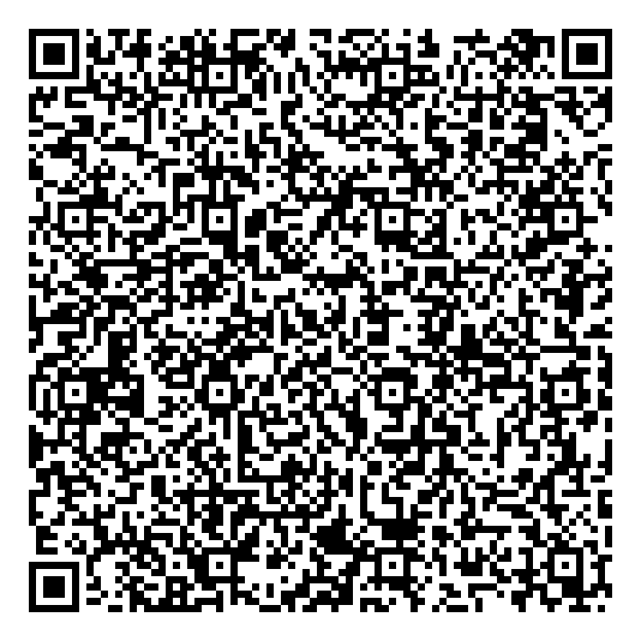
Ramadan times for Itegem, Belgium
Tue 17 Feb 2026 - Wed 18 Mar 2026
High Latitude Method: Angle Based Rule
Prayer Calculation Method: Muslim World League
Asar Calculation Method: Shafi

Date | Day | Fajr | Suhur | Sunrise | Dhuhr | Asr | Iftar | Maghrib | Isha
17 | Tue | 6:00 | 6:00 | 7:50 | 12:55 | 3:30 | 6:01 | 6:01 | 7:45
18 | Wed | 5:58 | 5:58 | 7:48 | 12:55 | 3:31 | 6:02 | 6:02 | 7:47
19 | Thu | 5:56 | 5:56 | 7:47 | 12:55 | 3:32 | 6:04 | 6:04 | 7:48
20 | Fri | 5:54 | 5:54 | 7:45 | 12:55 | 3:34 | 6:06 | 6:06 | 7:50
21 | Sat | 5:52 | 5:52 | 7:43 | 12:55 | 3:35 | 6:08 | 6:08 | 7:52
22 | Sun | 5:50 | 5:50 | 7:41 | 12:55 | 3:36 | 6:10 | 6:10 | 7:53
23 | Mon | 5:48 | 5:48 | 7:38 | 12:54 | 3:38 | 6:11 | 6:11 | 7:55
24 | Tue | 5:46 | 5:46 | 7:36 | 12:54 | 3:39 | 6:13 | 6:13 | 7:57
25 | Wed | 5:44 | 5:44 | 7:34 | 12:54 | 3:40 | 6:15 | 6:15 | 7:58
26 | Thu | 5:42 | 5:42 | 7:32 | 12:54 | 3:41 | 6:17 | 6:17 | 8:00
27 | Fri | 5:40 | 5:40 | 7:30 | 12:54 | 3:43 | 6:18 | 6:18 | 8:02
28 | Sat | 5:38 | 5:38 | 7:28 | 12:54 | 3:44 | 6:20 | 6:20 | 8:04
1 | Sun | 5:36 | 5:36 | 7:26 | 12:53 | 3:45 | 6:22 | 6:22 | 8:05
2 | Mon | 5:34 | 5:34 | 7:24 | 12:53 | 3:46 | 6:24 | 6:24 | 8:07
3 | Tue | 5:32 | 5:32 | 7:22 | 12:53 | 3:48 | 6:25 | 6:25 | 8:09
4 | Wed | 5:30 | 5:30 | 7:20 | 12:53 | 3:49 | 6:27 | 6:27 | 8:11
5 | Thu | 5:27 | 5:27 | 7:17 | 12:53 | 3:50 | 6:29 | 6:29 | 8:12
6 | Fri | 5:25 | 5:25 | 7:15 | 12:52 | 3:51 | 6:30 | 6:30 | 8:14
7 | Sat | 5:23 | 5:23 | 7:13 | 12:52 | 3:52 | 6:32 | 6:32 | 8:16
8 | Sun | 5:21 | 5:21 | 7:11 | 12:52 | 3:54 | 6:34 | 6:34 | 8:18
9 | Mon | 5:18 | 5:18 | 7:09 | 12:52 | 3:55 | 6:36 | 6:36 | 8:19
10 | Tue | 5:16 | 5:16 | 7:06 | 12:51 | 3:56 | 6:37 | 6:37 | 8:21
11 | Wed | 5:14 | 5:14 | 7:04 | 12:51 | 3:57 | 6:39 | 6:39 | 8:23
12 | Thu | 5:11 | 5:11 | 7:02 | 12:51 | 3:58 | 6:41 | 6:41 | 8:25
13 | Fri | 5:09 | 5:09 | 7:00 | 12:51 | 3:59 | 6:42 | 6:42 | 8:27
14 | Sat | 5:07 | 5:07 | 6:58 | 12:50 | 4:00 | 6:44 | 6:44 | 8:28
15 | Sun | 5:04 | 5:04 | 6:55 | 12:50 | 4:01 | 6:46 | 6:46 | 8:30
16 | Mon | 5:02 | 5:02 | 6:53 | 12:50 | 4:02 | 6:47 | 6:47 | 8:32
17 | Tue | 4:59 | 4:59 | 6:51 | 12:49 | 4:03 | 6:49 | 6:49 | 8:34
18 | Wed | 4:57 | 4:57 | 6:49 | 12:49 | 4:04 | 6:51 | 6:51 | 8:36
Prayer times provided by https://www.salahtimes.com

