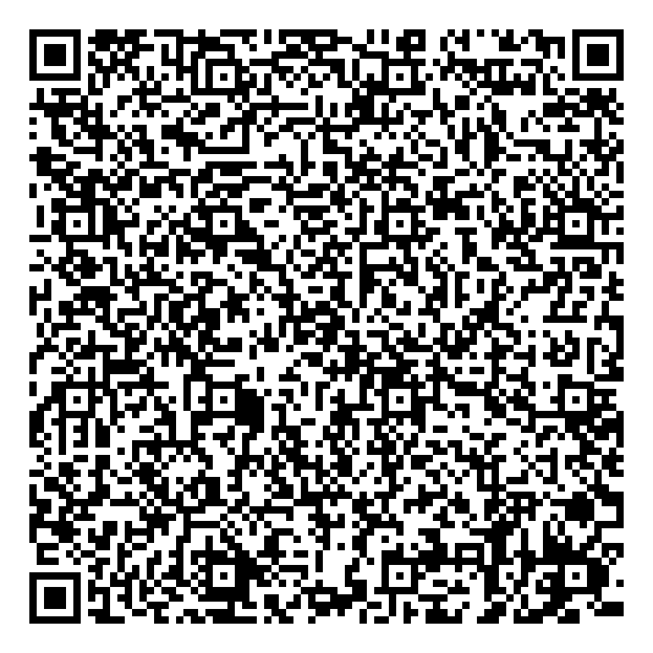
Ramadan times for Jollain Merlin, Belgium
Tue 17 Feb 2026 - Wed 18 Mar 2026
High Latitude Method: Angle Based Rule
Prayer Calculation Method: Muslim World League
Asar Calculation Method: Shafi

Date | Day | Fajr | Suhur | Sunrise | Dhuhr | Asr | Iftar | Maghrib | Isha
17 | Tue | 6:05 | 6:05 | 7:55 | 1:00 | 3:36 | 6:07 | 6:07 | 7:50
18 | Wed | 6:03 | 6:03 | 7:53 | 1:00 | 3:38 | 6:09 | 6:09 | 7:52
19 | Thu | 6:01 | 6:01 | 7:51 | 1:00 | 3:39 | 6:11 | 6:11 | 7:54
20 | Fri | 6:00 | 6:00 | 7:49 | 1:00 | 3:40 | 6:12 | 6:12 | 7:55
21 | Sat | 5:58 | 5:58 | 7:47 | 1:00 | 3:42 | 6:14 | 6:14 | 7:57
22 | Sun | 5:56 | 5:56 | 7:45 | 1:00 | 3:43 | 6:16 | 6:16 | 7:58
23 | Mon | 5:54 | 5:54 | 7:43 | 1:00 | 3:44 | 6:18 | 6:18 | 8:00
24 | Tue | 5:52 | 5:52 | 7:41 | 1:00 | 3:45 | 6:19 | 6:19 | 8:02
25 | Wed | 5:50 | 5:50 | 7:39 | 12:59 | 3:47 | 6:21 | 6:21 | 8:03
26 | Thu | 5:48 | 5:48 | 7:37 | 12:59 | 3:48 | 6:23 | 6:23 | 8:05
27 | Fri | 5:46 | 5:46 | 7:35 | 12:59 | 3:49 | 6:24 | 6:24 | 8:07
28 | Sat | 5:44 | 5:44 | 7:33 | 12:59 | 3:50 | 6:26 | 6:26 | 8:08
1 | Sun | 5:42 | 5:42 | 7:31 | 12:59 | 3:52 | 6:28 | 6:28 | 8:10
2 | Mon | 5:40 | 5:40 | 7:28 | 12:58 | 3:53 | 6:29 | 6:29 | 8:12
3 | Tue | 5:38 | 5:38 | 7:26 | 12:58 | 3:54 | 6:31 | 6:31 | 8:13
4 | Wed | 5:36 | 5:36 | 7:24 | 12:58 | 3:55 | 6:33 | 6:33 | 8:15
5 | Thu | 5:33 | 5:33 | 7:22 | 12:58 | 3:56 | 6:35 | 6:35 | 8:17
6 | Fri | 5:31 | 5:31 | 7:20 | 12:58 | 3:57 | 6:36 | 6:36 | 8:19
7 | Sat | 5:29 | 5:29 | 7:18 | 12:57 | 3:59 | 6:38 | 6:38 | 8:20
8 | Sun | 5:27 | 5:27 | 7:16 | 12:57 | 4:00 | 6:40 | 6:40 | 8:22
9 | Mon | 5:25 | 5:25 | 7:14 | 12:57 | 4:01 | 6:41 | 6:41 | 8:24
10 | Tue | 5:22 | 5:22 | 7:11 | 12:57 | 4:02 | 6:43 | 6:43 | 8:26
11 | Wed | 5:20 | 5:20 | 7:09 | 12:56 | 4:03 | 6:45 | 6:45 | 8:27
12 | Thu | 5:18 | 5:18 | 7:07 | 12:56 | 4:04 | 6:46 | 6:46 | 8:29
13 | Fri | 5:15 | 5:15 | 7:05 | 12:56 | 4:05 | 6:48 | 6:48 | 8:31
14 | Sat | 5:13 | 5:13 | 7:03 | 12:56 | 4:06 | 6:49 | 6:49 | 8:33
15 | Sun | 5:11 | 5:11 | 7:00 | 12:55 | 4:07 | 6:51 | 6:51 | 8:34
16 | Mon | 5:08 | 5:08 | 6:58 | 12:55 | 4:08 | 6:53 | 6:53 | 8:36
17 | Tue | 5:06 | 5:06 | 6:56 | 12:55 | 4:09 | 6:54 | 6:54 | 8:38
18 | Wed | 5:03 | 5:03 | 6:54 | 12:54 | 4:10 | 6:56 | 6:56 | 8:40
Prayer times provided by https://www.salahtimes.com

