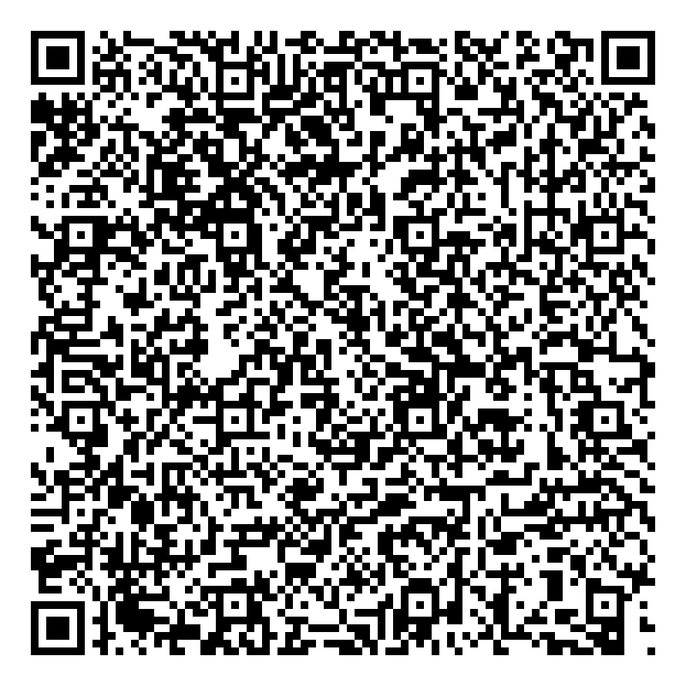
Ramadan times for Alvakay I, Cameroon
Tue 17 Feb 2026 - Wed 18 Mar 2026
High Latitude Method: None
Prayer Calculation Method: Muslim World League
Asar Calculation Method: Shafi

Date | Day | Fajr | Suhur | Sunrise | Dhuhr | Asr | Iftar | Maghrib | Isha
17 | Tue | 5:09 | 5:09 | 6:20 | 12:14 | 3:35 | 6:08 | 6:08 | 7:15
18 | Wed | 5:09 | 5:09 | 6:20 | 12:14 | 3:35 | 6:08 | 6:08 | 7:15
19 | Thu | 5:08 | 5:08 | 6:19 | 12:14 | 3:35 | 6:08 | 6:08 | 7:15
20 | Fri | 5:08 | 5:08 | 6:19 | 12:14 | 3:35 | 6:09 | 6:09 | 7:15
21 | Sat | 5:08 | 5:08 | 6:19 | 12:14 | 3:34 | 6:09 | 6:09 | 7:16
22 | Sun | 5:07 | 5:07 | 6:18 | 12:13 | 3:34 | 6:09 | 6:09 | 7:16
23 | Mon | 5:07 | 5:07 | 6:18 | 12:13 | 3:34 | 6:09 | 6:09 | 7:16
24 | Tue | 5:07 | 5:07 | 6:17 | 12:13 | 3:34 | 6:09 | 6:09 | 7:16
25 | Wed | 5:06 | 5:06 | 6:17 | 12:13 | 3:34 | 6:09 | 6:09 | 7:16
26 | Thu | 5:06 | 5:06 | 6:16 | 12:13 | 3:33 | 6:10 | 6:10 | 7:16
27 | Fri | 5:05 | 5:05 | 6:16 | 12:13 | 3:33 | 6:10 | 6:10 | 7:16
28 | Sat | 5:05 | 5:05 | 6:15 | 12:13 | 3:33 | 6:10 | 6:10 | 7:16
1 | Sun | 5:05 | 5:05 | 6:15 | 12:12 | 3:33 | 6:10 | 6:10 | 7:16
2 | Mon | 5:04 | 5:04 | 6:14 | 12:12 | 3:32 | 6:10 | 6:10 | 7:16
3 | Tue | 5:04 | 5:04 | 6:14 | 12:12 | 3:32 | 6:10 | 6:10 | 7:16
4 | Wed | 5:03 | 5:03 | 6:13 | 12:12 | 3:32 | 6:10 | 6:10 | 7:16
5 | Thu | 5:03 | 5:03 | 6:13 | 12:12 | 3:31 | 6:10 | 6:10 | 7:16
6 | Fri | 5:02 | 5:02 | 6:12 | 12:11 | 3:31 | 6:10 | 6:10 | 7:16
7 | Sat | 5:02 | 5:02 | 6:12 | 12:11 | 3:31 | 6:10 | 6:10 | 7:16
8 | Sun | 5:01 | 5:01 | 6:11 | 12:11 | 3:30 | 6:10 | 6:10 | 7:16
9 | Mon | 5:01 | 5:01 | 6:11 | 12:11 | 3:30 | 6:11 | 6:11 | 7:16
10 | Tue | 5:00 | 5:00 | 6:10 | 12:10 | 3:29 | 6:11 | 6:11 | 7:17
11 | Wed | 5:00 | 5:00 | 6:10 | 12:10 | 3:29 | 6:11 | 6:11 | 7:17
12 | Thu | 4:59 | 4:59 | 6:09 | 12:10 | 3:28 | 6:11 | 6:11 | 7:17
13 | Fri | 4:58 | 4:58 | 6:08 | 12:10 | 3:28 | 6:11 | 6:11 | 7:17
14 | Sat | 4:58 | 4:58 | 6:08 | 12:09 | 3:27 | 6:11 | 6:11 | 7:17
15 | Sun | 4:57 | 4:57 | 6:07 | 12:09 | 3:27 | 6:11 | 6:11 | 7:17
16 | Mon | 4:57 | 4:57 | 6:07 | 12:09 | 3:26 | 6:11 | 6:11 | 7:17
17 | Tue | 4:56 | 4:56 | 6:06 | 12:08 | 3:26 | 6:11 | 6:11 | 7:17
18 | Wed | 4:56 | 4:56 | 6:06 | 12:08 | 3:25 | 6:11 | 6:11 | 7:17
Prayer times provided by https://www.salahtimes.com

