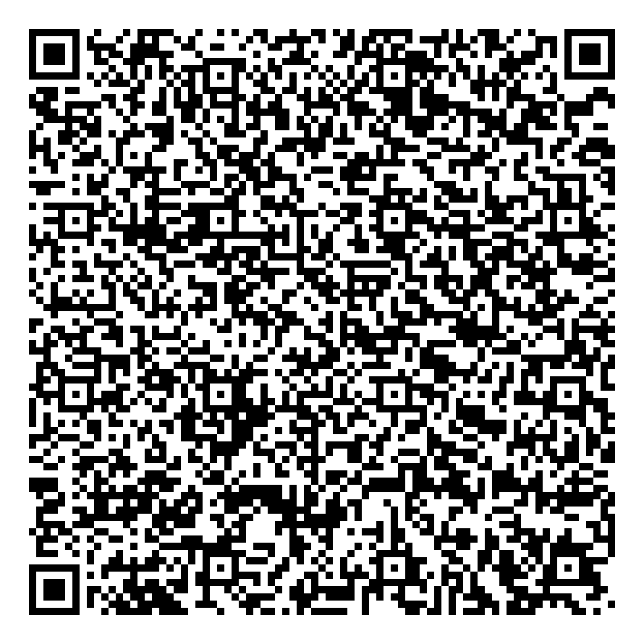

**Ramadan times for Klein-Tichelarij, Belgium**

**Tue 17 Feb 2026 - Wed 18 Mar 2026**

**High Latitude Method: Angle Based Rule**

**Prayer Calculation Method: Muslim World League**

**Asar Calculation Method: Shafi**

|  |  |  |  |  |  |  |  |  |  |
| --- | --- | --- | --- | --- | --- | --- | --- | --- | --- |
| **Date** | **Day** | **Fajr** | **Suhur** | **Sunrise** | **Dhuhr** | **Asr** | **Iftar** | **Maghrib** | **Isha** |
| 17 | Tue | 5:58 | 5:58 | 7:48 | 12:53 | 3:28 | 5:59 | 5:59 | 7:43 |
| 18 | Wed | 5:56 | 5:56 | 7:46 | 12:53 | 3:30 | 6:01 | 6:01 | 7:45 |
| 19 | Thu | 5:54 | 5:54 | 7:44 | 12:53 | 3:31 | 6:03 | 6:03 | 7:46 |
| 20 | Fri | 5:52 | 5:52 | 7:42 | 12:53 | 3:32 | 6:05 | 6:05 | 7:48 |
| 21 | Sat | 5:50 | 5:50 | 7:40 | 12:53 | 3:34 | 6:06 | 6:06 | 7:50 |
| 22 | Sun | 5:49 | 5:49 | 7:38 | 12:53 | 3:35 | 6:08 | 6:08 | 7:51 |
| 23 | Mon | 5:47 | 5:47 | 7:36 | 12:53 | 3:36 | 6:10 | 6:10 | 7:53 |
| 24 | Tue | 5:45 | 5:45 | 7:34 | 12:52 | 3:37 | 6:12 | 6:12 | 7:55 |
| 25 | Wed | 5:43 | 5:43 | 7:32 | 12:52 | 3:39 | 6:13 | 6:13 | 7:56 |
| 26 | Thu | 5:41 | 5:41 | 7:30 | 12:52 | 3:40 | 6:15 | 6:15 | 7:58 |
| 27 | Fri | 5:39 | 5:39 | 7:28 | 12:52 | 3:41 | 6:17 | 6:17 | 8:00 |
| 28 | Sat | 5:37 | 5:37 | 7:26 | 12:52 | 3:43 | 6:18 | 6:18 | 8:02 |
| 1 | Sun | 5:34 | 5:34 | 7:24 | 12:52 | 3:44 | 6:20 | 6:20 | 8:03 |
| 2 | Mon | 5:32 | 5:32 | 7:22 | 12:51 | 3:45 | 6:22 | 6:22 | 8:05 |
| 3 | Tue | 5:30 | 5:30 | 7:20 | 12:51 | 3:46 | 6:24 | 6:24 | 8:07 |
| 4 | Wed | 5:28 | 5:28 | 7:17 | 12:51 | 3:47 | 6:25 | 6:25 | 8:08 |
| 5 | Thu | 5:26 | 5:26 | 7:15 | 12:51 | 3:49 | 6:27 | 6:27 | 8:10 |
| 6 | Fri | 5:24 | 5:24 | 7:13 | 12:50 | 3:50 | 6:29 | 6:29 | 8:12 |
| 7 | Sat | 5:21 | 5:21 | 7:11 | 12:50 | 3:51 | 6:30 | 6:30 | 8:14 |
| 8 | Sun | 5:19 | 5:19 | 7:09 | 12:50 | 3:52 | 6:32 | 6:32 | 8:15 |
| 9 | Mon | 5:17 | 5:17 | 7:07 | 12:50 | 3:53 | 6:34 | 6:34 | 8:17 |
| 10 | Tue | 5:15 | 5:15 | 7:04 | 12:50 | 3:54 | 6:36 | 6:36 | 8:19 |
| 11 | Wed | 5:12 | 5:12 | 7:02 | 12:49 | 3:55 | 6:37 | 6:37 | 8:21 |
| 12 | Thu | 5:10 | 5:10 | 7:00 | 12:49 | 3:57 | 6:39 | 6:39 | 8:23 |
| 13 | Fri | 5:08 | 5:08 | 6:58 | 12:49 | 3:58 | 6:41 | 6:41 | 8:24 |
| 14 | Sat | 5:05 | 5:05 | 6:56 | 12:48 | 3:59 | 6:42 | 6:42 | 8:26 |
| 15 | Sun | 5:03 | 5:03 | 6:53 | 12:48 | 4:00 | 6:44 | 6:44 | 8:28 |
| 16 | Mon | 5:00 | 5:00 | 6:51 | 12:48 | 4:01 | 6:46 | 6:46 | 8:30 |
| 17 | Tue | 4:58 | 4:58 | 6:49 | 12:48 | 4:02 | 6:47 | 6:47 | 8:32 |
| 18 | Wed | 4:55 | 4:55 | 6:47 | 12:47 | 4:03 | 6:49 | 6:49 | 8:34 |

**Prayer times provided by https://www.salahtimes.com**